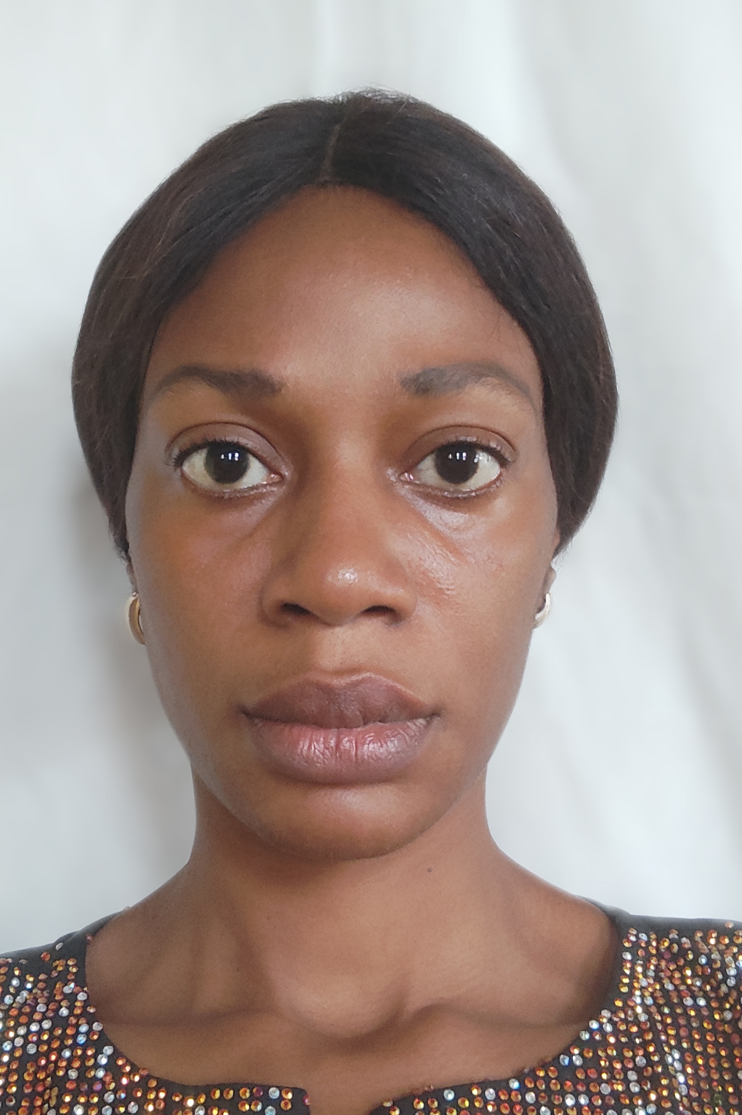
IJEOMA DIMUDE
14a Church Street (St Paul’s) Canterbury, Kent.
Phone: +447-776761487
E-mail: ejaynblessing@gmail.com

Nationality: Nigerian

Profile
A creative and attentive to detail oriented individual with ability to work and Learn. I am very confident, hands-on, coordinated, and resourceful. I communicate effectively with clients/customers to ensure that their needs are met and desires achieved. I am also self-motivated, diligent and understanding with a strong dedication to caring for others.

Personal Details
- Eligible to work in the UK: Yes

Key Qualifications
- Exceptional skill in the use of Microsoft Office Suite (Word, Excel)
- High sense of commitment, diligence and self-motivating ability.
- Good communication (oral and writing) skill.
- Highly creative, resourceful, team player and takes initiatives.
- Always ready to help
- Customer -oriented and friendly.

Employments

2015- 2022 MARTHA’S HOUSE INTERIOR

Interior Design Projects:

- Product and Material sourcing which includes, interior accessories, window treatments, light fittings and exterior Materials etc.
- Researched Vendors and maintained a catalogue of materials, vendors and Contractors for future projects.
- Consultation, 3D rendering for internal design review.
- Sourcing all color selection, installation of window treatments and tile selections.

2012 -2013 AQUADRILL LIMITED
Lagos State, Nigeria
Front Desk/ Administrative Officer
- Providing customer service
- Handling files and making sure they are well arranged and kept properly.
- Receiving phones calls.
- Other duties as assigned by the Management from time to time.

2009 – 2012 TRLPLAW (International Commercial Lawyers)
Lagos State
Front Desk/ Receptionist
  - Handling of tasks and providing customer service
  - Assist and support processing payroll records
  - Handing files and making sure they are well arranged and kept properly.
  - Receiving phones calls and scheduling meetings.
  - Keeping records of the cases coming up in court.
  - Attending to clients of the Firm.
  - Other duties as assigned by the Management from time to time.

HOBBIES: Charitable Works, Making New Friends, Adventures,

Education and Certifications

2022 - 2023 The University for the Creative Arts -(Current)
MA Interior Design - Pending

2019 National Open University Nigeria
Bsc Mass Communication
2012 The Maven School of Interior Decoration and Design
3 Month Professional Course in Interior Design and Decoration
2005 University of Jos
Diploma in Theatre Arts
2000 Holy Rosary College, Enugu State

LANGUAGES: Speaking Reading Writing
English Fluent Fluent Fluent
Igbo Good Fair Fair

REFERENCES

1.Mrs Eucharia Udoji
Support Worker
+447 903716655

- Mr Pascal Ezennakwe
DIRECTOR
+447 903226397

- Mr Oluwaseun Arogundade
Self Employed Contractor
+447 7503980712

