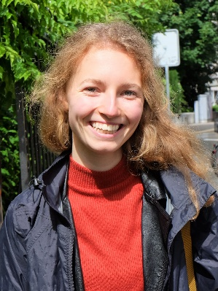
Personal profile
Name Carlijn Keijzer
Phone +31 6 27119951
E-mail carlijn_keijzer@hotmail.com
Nationality Dutch
Date of birth 13-03-1996
Work experience
2019 Kitchen assistant
Domaine de la Noguiere, France
2018 - 2019 Waitress and bar staff
Pernikkel, Groningen
2016 Housekeeper
Bastion hotel, Groningen

Academic history
2015 – 2018 Bachelor Liberal Arts and Sciences, major in Cognition and Behaviour. Graduated cum laude.
University of Groningen
2017 Exchange semester
Victoria University of Wellington, New Zealand
2014 Advanced English plus Academic Subjects
St. Clare’s, Oxford
2008 – 2014 Highschool education (VWO diploma)
Marnix Gymnasium, Rotterdam

